Common Core State Standard (s) or Sunshine State Standard (s):
03.0 Develop and apply electronic presentation skills utilizing current technology – the student will be able to:
03.01 Demonstrate ability to launch presentation software.
03.02 Create a new presentation document.
03.03 Identify menus and toolbars of presentation software and their function.
03.04 Select design layout, background, template and color scheme.
03.05 Format text and graphics.
  - Edit text.
03.07 Select order of frames.
Daily Lesson Learning Goal(s):
Students will be able to apply themes, insert new slides, and change the slide layout of PowerPoint 2016 presentations in order to enhance digital communication.
Objective:
Students will feel comfortable with tasks such as inserting a new slides, changing the layout of a slide, arranging existing slides, changing the slide view, and adding notes to a slide.
Essential Vocabulary:
Slide Layout, Content Placeholder, Slide View, Reading View, Normal View, Presentation Mode, Slide Sorter, Slide Navigation Pane, Text Box, Slide Size, Standard, Widescreen
Guided Practice:
Students will log into Edmodo for learning goal and directions. Students will access links in Blendspace
https://www.tes.com/lessons/ptYjsB_Z-gqvOw/copy-of-powerpoint-2016-slide-basics
Independent Practice:
- Open the practice presentation
- Perform a Save As and choose your student numbers as a file location and change the name of the document to Slide Basics
- Change the theme of the presentation to a theme of your choice.
- Specify a variant for that theme of your choice.
- Delete slide 7. This slide should be blank.
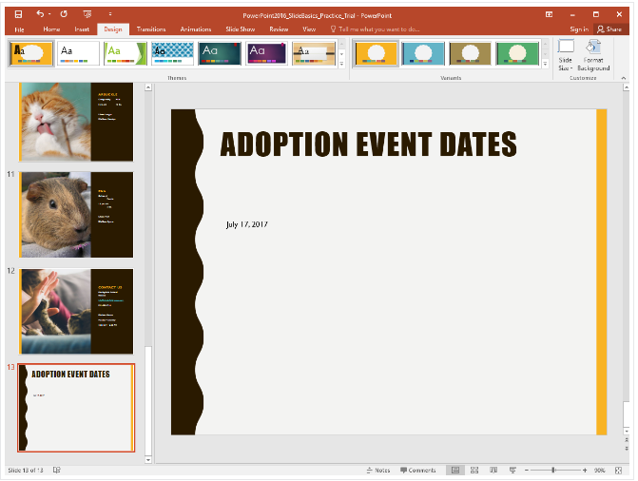
- Add a new slide with the Title and Content layout to the end of the presentation.
- In the Title placeholder, type Adoption Event Dates.
- Select the Content placeholder and delete it.
- Insert a text box and type July 17, 2017, inside it.
- Change the slide size to Standard (4:3). A dialog box will appear asking if you want to maximize or ensure fit. Choose Ensure Fit.
- Make 3 of your own slides with some of your favorite characters from television. For example, if Psyduck from Pokemon needed a new home, what would his adoption slide look like?
- When you're finished it should look something like the picture below, save your presentation and turn this into your Edmodo account

