November is Diabetes Awareness Month! Peruse through at your leisure for tons of resources to use in your classroom!

Florida Health Literacy Initiative Teaching About Diabetes Toolkit November 2019

- Student Research and Discussion Questions
  - What is diabetes? Explain why untreated diabetes is dangerous.
  - Why don’t all carbohydrates affect blood glucose (sugar) in the same way?
  - What is the difference between a simple carbohydrate and a complex carbohydrate?
  - How can people decrease their chances of developing diabetes?

- Diabetes Vocabulary Words (English and Spanish) –
https://kidshealth.org/en/teens/diabetes-center/#catwords-to-know

- Diabetes Overview Video
CDC - https://www.youtube.com/watch?v=wmOW091P2ew
UK Government - https://www.youtube.com/watch?v=wZAjVQWbMlE

- Class Activities Relating to Diabetes
  - Blood Sugar Math Activity – page 87 Staying Healthy Teacher’s Guide (Blue Book)
  - Technology Activity – page 97 Staying Healthy Teacher’s Guide (Blue Book)
  - Classroom Toolkit – Great plain language handouts and activities. Some of this is geared to small children but the majority is appropriate for adults as well. http://www2.jdrf.org/site/DocServer/Kids_Walk_ClassroomToolkit.pdf?docID=1086

- Diabetes Articles for student reading and discussion
https://www.cdc.gov/diabetes/diabetesatwork/pdfs/DiabetesWhatIsIt.pdf

https://www.diabeteseducator.org/docs/default-source/living-with-diabetes/tip- sheets/cardiovascular-disease/cvdprevention.pdf?sfvrsn=12

http://schoolwalk.diabetes.org/swfd/swfd_factory.pdf

- 50 Ways to Prevent Type 2 Diabetes – This list is a good conversation starter. Have students pick a few factors to they can improve.
https://www.niddk.nih.gov/health-information/diabetes/overview/preventing-type-2- diabetes/50-ways

- Prediabetes Video explaining how to calculate personal risk –
https://www.youtube.com/watch?v=n2VyBnEAx7E

- Personal Story of a Woman’s Journey to Health after being diagnosed with prediabetes – 3 ½ minute video
https://www.youtube.com/watch?v=uyHuEG3ZegU

- Infographics (See below)
  - Choosing Whole Grains over Refined Grains
  - Prediabetes
  - Diabetes short version and Long Version

What Is Diabetes?
https://teenshealth.org/en/teens/prevention.html (available in Spanish and English with audio)

Diabetes is a disease that affects how the body uses glucose, a sugar that is the body's main source of fuel. Your body needs glucose to keep running. Here's how it should work.

- You eat.

- Glucose from the food gets into your bloodstream.

- Your pancreas makes a hormone called insulin.
- Insulin helps the glucose get into the body's cells.

- Your body gets the energy it needs.

The pancreas is a long, flat gland in your belly that helps your body digest food. It also makes insulin. Insulin is kind of like a key that opens the doors to the cells of the body. It lets the glucose in. Then the glucose can move out of the blood and into the cells.

But if someone has diabetes, the body either can't make insulin (this is called type 1 diabetes) or the insulin doesn't work in the body like it should (this is called type 2 diabetes). The glucose can't get into the cells normally, so the blood sugar level gets too high. Lots of sugar in the blood makes people sick if they don't get treatment.

Can Type 1 Diabetes Be Prevented?

Type 1 diabetes can't be prevented. Doctors can't even tell who will get it and who won't.

In type 1 diabetes, a person's immune system attacks the pancreas and destroys the cells that make insulin. No one knows for sure why this happens, but scientists think it has something to do
with genes. Genes are like instructions for how the body should look and work that are passed on by parents to their kids. But just getting the genes for diabetes isn't usually enough. In most cases, something else has to happen — like getting a virus infection — for a person to get type 1 diabetes.

Type 1 diabetes isn't contagious, so you can't catch it from another person or pass it along to your friends. And stuff like eating too much sugar doesn't cause type 1 diabetes.

Can Type 2 Diabetes Be Prevented?

Type 2 diabetes is different. Sometimes, type 2 diabetes can be prevented.

In type 2 diabetes, the pancreas can still make insulin, but the body doesn't respond to it in the right way. This problem is usually related to being overweight. In the past, mainly overweight adults developed type 2 diabetes. Today, more kids and teens have type 2 diabetes, probably because more kids and teens are overweight.
Getting to a healthy weight is one way to help prevent type 2 diabetes. Making healthy food choices and getting enough exercise are other good steps to take. If a person makes better food choices and becomes more physically active, it can help prevent diabetes from becoming a problem.

Some people are more likely to get type 2 diabetes than others based on things that can't be changed. For example, people with a Native American, African, Hispanic/Latino, or Asian/Pacific Islander racial/ethnic background are at higher risk for getting type 2 diabetes. And people who have family members with type 2 diabetes are also more likely to develop it.

How Can I Protect Myself From Getting Type 2 Diabetes?

If you want to help keep yourself from getting type 2 diabetes — or just be healthier in lots of other ways — take these steps:

- Eat good-for-you foods. Try to eat foods that are low in fat and high in other nutrients — like whole-grain cereals and breads, fruits, vegetables, dairy products, and lean proteins. These super foods provide you with the nutrition you need to grow, but are also great for helping you get to or stay at a healthy weight, which can help prevent type 2 diabetes.
- Limit fast food and sugary sodas. Eating lots of calorie-laden fast food and sugar- filled beverages — like sodas, juices, and iced teas — can lead to a lot of weight gain.
- Get up and go. Staying active and decreasing the amount of time spent in sedentary activities (like watching TV, being online, or playing video or computer games) can also help to prevent type 2 diabetes. You don't need to join a gym or commit to three sports every school year — being active can be as simple as walking the dog or mowing the lawn. Try to do something that gets you moving every day.
- If you have questions about your weight, ask. If you think you may be overweight or you're just wondering what being healthy is all about, a doctor or a registered dietitian can help. These health care pros can help you find out what your weight goals should be and how to get there — and stay there.

PREDIABETES
1
3
COULD IT
BE YOU?

84.1
MILLION

84.1 million American adults — more than
1 out of 3 — have prediabetes

OUT OF

9

OUT OF
10
people with prediabetes don’t know they have it

TYPE 2 DIABETES

PREDIABETES
Prediabetes is when your blood sugar level is higher than normal but not high enough yet to
Prediabetes increases your risk of:

NORMAL
be diagnosed as type 2 diabetes
TYPE 2
DIABETES
HEART
DISEASE
STROKE

If you have prediabetes, losing weight by:

EATING HEALTHY
&

BEING MORE ACTIVE
can cut your risk of getting type 2 diabetes in
HA LF

Ignore prediabetes and type 2 diabetes risk goes up — and so does risk for serious health complications:

BLINDNESS KIDNEY FAILURE
HEART DISEASE
STROKE LOSS OF TOES, FEET, OR LEGS

YOU CAN PREVENT TYPE 2 DIABETES

FIND OUT IF YOU HAVE PREDIABETES —
See your doctor to get your blood sugar tested

eat healthy
be more active lose weight
JOIN A CDC- RECOGNIZED
diabetes prevention program

LEARN MORE FROM CDC AND TAKE THE PREDIABETES RISK QUIZ AT
www.cdc.gov/diabetes/basics/prediabetes.html

REFERENCES

Centers for Disease Control and Prevention. National Diabetes Statistics Report: Estimates of Diabetes and Its Burden in the United States, 2017. Atlanta, GA: U.S. Department of Health and Human Services; 2017.
Centers for Disease Control and Prevention, National Center for Health Statistics. Underlying Cause of Death 1999-2015 on CDC WONDER Online Database, released December, 2016. Data are from the Multiple Cause of Death Files, 1999-2015, as compiled from data provided by the 57 vital statistics jurisdictions through the Vital Statistics Cooperative Program. Accessed at http://wonder.cdc.gov/ucd-icd10.html on April 4, 2017.

CDC’s Division of Diabetes Translation works toward a world free of the devastation of diabetes.

CS279453C

A SNAPSHOT
DIABETES
IN THE UNITED STATES

DIABETES
1

30.3 30.3 million
MILLION
people have diabetes
That's about 1 out of every 10 people

don’t know

OF 4 OUT

they have diabetes

can cut your risk of getting type 2 diabetes in
HA LF
PREDIABETES
MILLION
84.1

84.1 million people —
more than 1 out of 3 adults —
have prediabetes
9
OUT OF
10
don’t know they
have prediabetes
If you have prediabetes, losing weight by:
EATING HEALTHY
&
BEING MORE ACTIVE
COST
$245
BILLION
Total medical costs and lost work and wages for people
with diagnosed diabetes

Risk of death for adults with
diabetes is
50%
HIGHER
than for adults without diabetes

Medical costs for people with diabetes are more than twice as high
as for people
without diabetes
2X
People who have diabetes are at higher risk of serious health complications:
BLINDNESS
KIDNEY FAILURE
HEART DISEASE
STROKE LOSS OF TOES, FEET,
OR LEGS

TYPES OF DIABETES

TYPE 1

TYPE 2

BODY DOESN'T MAKE ENOUGH INSULIN
- Can develop at any age
- No known way to prevent it

BODY CAN'T USE INSULIN PROPERLY
- Can develop at any age
- Most cases can be prevented

Nearly 18,000 youth diagnosed each year in 2011 and 2012

In adults, type 2 diabetes accounts for approximately
95

%
of all diagnosed
cases of diabetes

In adults, type 1 diabetes accounts for approximately

%
5
of all diagnosed
cases of diabetes

More than 5,000 youth diagnosed each year in 2011 and 2012

MILLION
1.5

People 18 years and older diagnosed
in 2015
RISK FACTORS FOR TYPE 2 DIABETES:

45

BEING
OVERWEIGHT

WHAT CAN YOU DO?
HAVING A FAMILY HISTORY
BEING
PHYSICALLY INACTIVE
BEING 45 AND OLDER

You can prevent or delay type 2 diabetes You can manage diabetes

LOSE WEIGHT
IF NEEDED

EAT
HEALTHY

BE MORE ACTIVE
WORK WITH A
HEALTH
PROFESSIONAL

EAT
HEALTHY

STAY ACTIVE

LEARN MORE AT www.cdc.gov/diabetes/prevention
OR SPEAK TO YOUR DOCTOR
LEARN MORE AT www.cdc.gov/diabetes/ndep
OR SPEAK TO YOUR DOCTOR

REFERENCES

Centers for Disease Control and Prevention. National Diabetes Statistics Report: Estimates of Diabetes and Its Burden in the United States, 2017. Atlanta, GA: U.S. Department of Health and Human Services; 2017.
American Diabetes Association. Economic Costs of Diabetes in the U.S. in 2012. Diabetes Care. 2013;36(4):1033-1046.
Centers for Disease Control and Prevention, National Center for Health Statistics. Underlying Cause of Death 1999-2015 on CDC WONDER Online Database, released December, 2016. Data are from the Multiple Cause of Death Files, 1999-2015, as compiled from data provided by the 57 vital statistics jurisdictions through the Vital Statistics Cooperative Program. Accessed at http://wonder.cdc.gov/ucd-icd10.html on April 4, 2017.
Mayer-Davis EJ, Lawrence JM, Dabelea D, Divers J, Isom S, Dolan L, et al. Incidence Trends of Type 1 and Type 2 Diabetes among Youths, 2002–2012. N Engl J Med. 2017;376:1419-29.

CDC’s Division of Diabetes Translation works toward a world free of the devastation of diabetes.
CS279453B

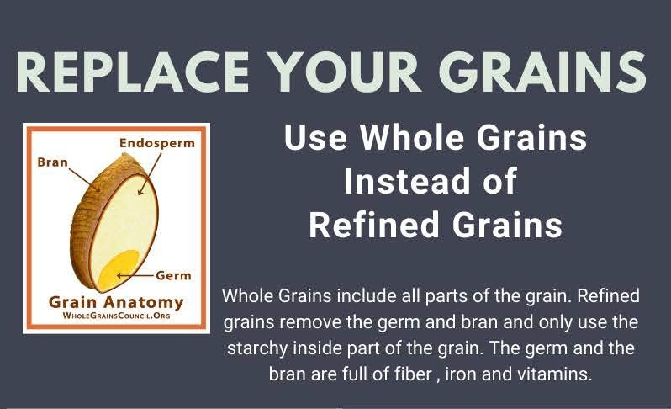
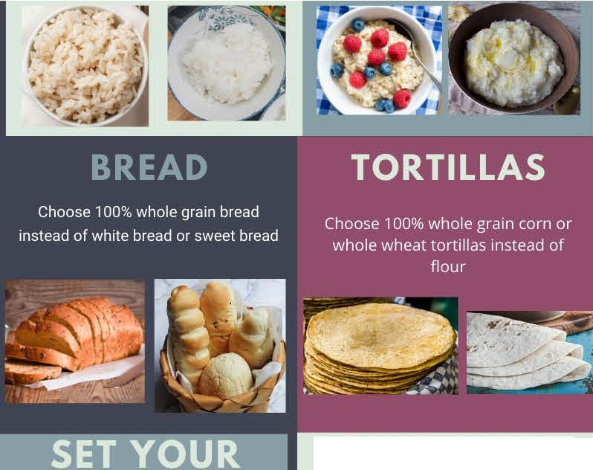

RICE

Use brown rice instead of white rice

TRY A NEW WHOLE GRAIN

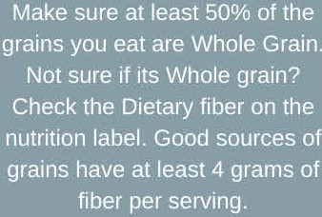
Homemade Popcorn Quinoa
Bulger (cracked wheat) Wheat Berries Amaranth
Farro Freekeh Teff
Black Rice

KNOW THE LINGO
.more than one type of grain. May riotbe whole grain.
Multigrain - a food tha.t cont ains
.Refined grains - conta in only the kernel's innermost part,.
Fortified products - cont ain added nutrients that weren't.in the original product

Enriched products - have had some of the original nutrients lost during processing added back in: This is not as healthy as eating the original food.
For more info, visit the Florida Literacy Coalition at floridaliteracy.org

National Diabetes Month 2019 – Downloadable Social Media Posts

 | FACEBOOK POST | INSTAGRAM POST | TWITTER POST
Shareable Social Media Post #1 | 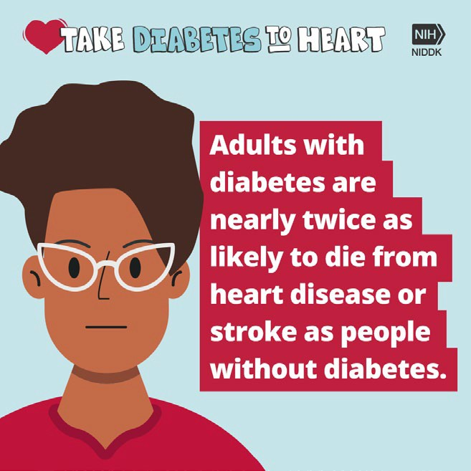  November is National Diabetes Month! How much do you know about the link between diabetes and heart disease? Learn more from  @NIDDKgov: https://www.niddk.nih.gov/health- information/communication-programs/ndep/partner-community- organization-information/national-diabetes-month/ | November is #NationalDiabetesMonth! How much do you know about the link between #diabetes and #HeartDisease? Learn more from the National Institute of Diabetes and Digestive and Kidney Diseases (NIDDK) at niddk.nih.gov. | 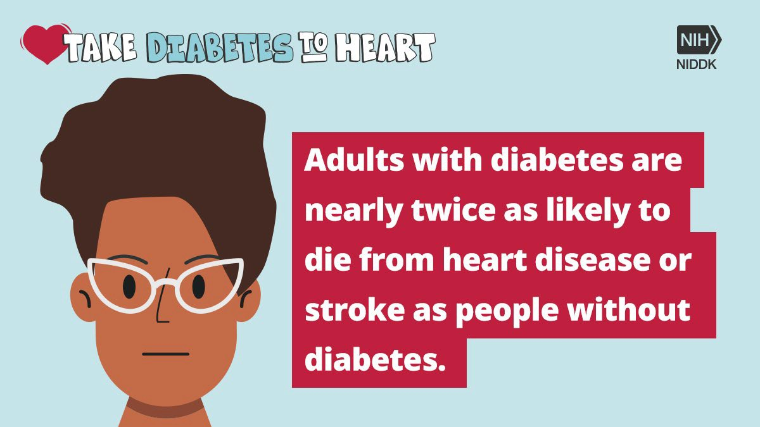  November is National #DiabetesMonth! How much do you know about the link between #diabetes and #HeartDisease? Learn more from @NIDDKgov: https://www.niddk.nih.gov/health- information/communication-programs/ndep/partner- community-organization-information/national-diabetes- month/

 | FACEBOOK POST | INSTAGRAM POST | TWITTER POST
Shareable Social Media Post #2 | 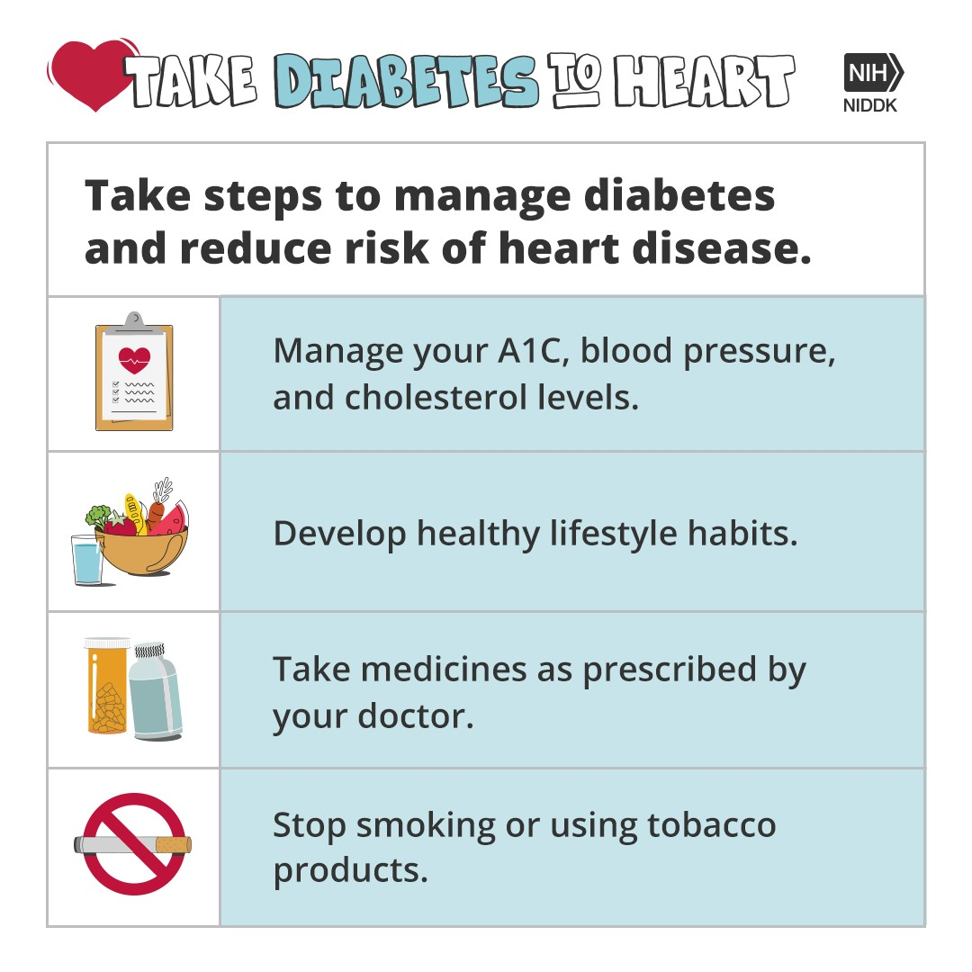  Adults with diabetes tend to develop heart disease at a younger age, and their most common causes of death are heart disease and stroke. This National Diabetes Month take steps from @NIDDKgov to reduce your risk. https://www.niddk.nih.gov/health- information/communication-programs/ndep/partner-community- organization-information/national-diabetes-month/ | Adults with #diabetes tend to develop #HeartDisease at a younger age, and their most common causes of death are heart disease and stroke. This #NationalDiabetesMonth take steps from the @National Institute of Diabetes and Digestive and Kidney Diseases (NIDDK) to reduce your heart disease risk. Visit niddk.nih.gov to learn more. #DiabetesMonth | 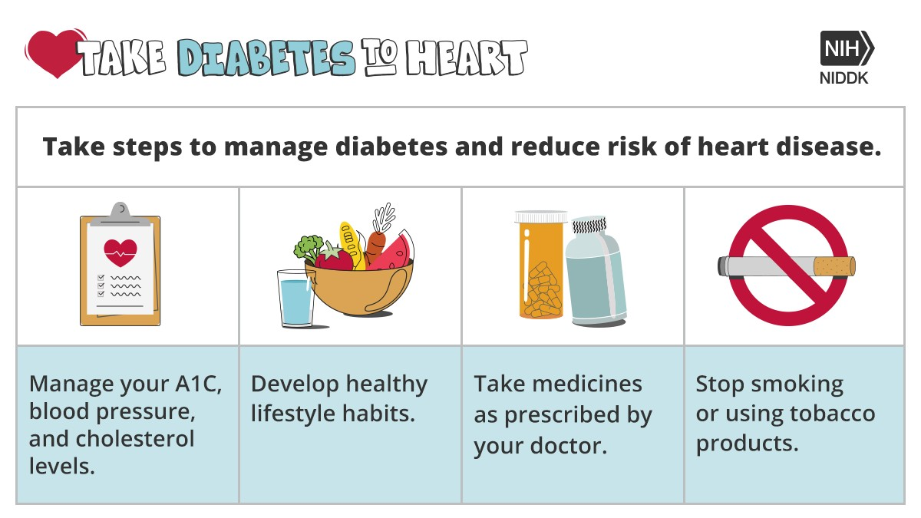  Adults with #diabetes tend to develop #HeartDisease at a younger age, and their most common causes of death are heart disease and stroke. This National #DiabetesMonth take steps from @NIDDKgov to reduce your heart disease. https://www.niddk.nih.gov/health- information/communication-programs/ndep/partner- community-organization-information/national-diabetes- month/

